### Intro

The motivation for this project comes from our group’s interest in applying deep learning to help physical activity; all of us either like working out at the gym or running. This project’s goal is to use machine learning to identify what yoga pose is represented in an image.

(importance)

It’s important for two reasons. First, this work could help users self-learn and practice yoga by identifying how well they are doing a pose. Although this project cannot replace yoga lessons or instructional videos, we are hopeful that it could help yoga enthusiasts as an extra tool to prevent injury and track progress on a pose. As a similar project states, [“Analyzing human posture can identify and rectify abnormal positions, improving well-being at home”](https://link-springer-com.myaccess.library.utoronto.ca/article/10.1007/s42452-023-05581-8).

Secondly, this yoga pose classification model is a building block for other applications. For example, the deep learning model could be adapted to track posture in other physical activities we’re interested in, like paddling and skateboarding. Moreover, we could build additional features on top of the model; related projects further identify yoga poses in videos [Yoga Trainer App using Human Pose Detection], [Deep Learning-Based Yoga Posture Recognition Using the Y_PN-MSSD Model for Yoga Practitioners] or send scores and feedback based on user’s poses like an actual instructor.

Finally, deep learning is an appropriate approach because it excels at image classification problems like determining if an image is a goat. Through training, a deep learning model is flexible enough to identify the same pose performed by different people in different settings with different clothes.

### Trash

Secondly, this project could guide development of similar deep learning models for posture in other physical activities we’re interested in, like paddling and skateboarding. Moreover, yoga pose classification can further help

[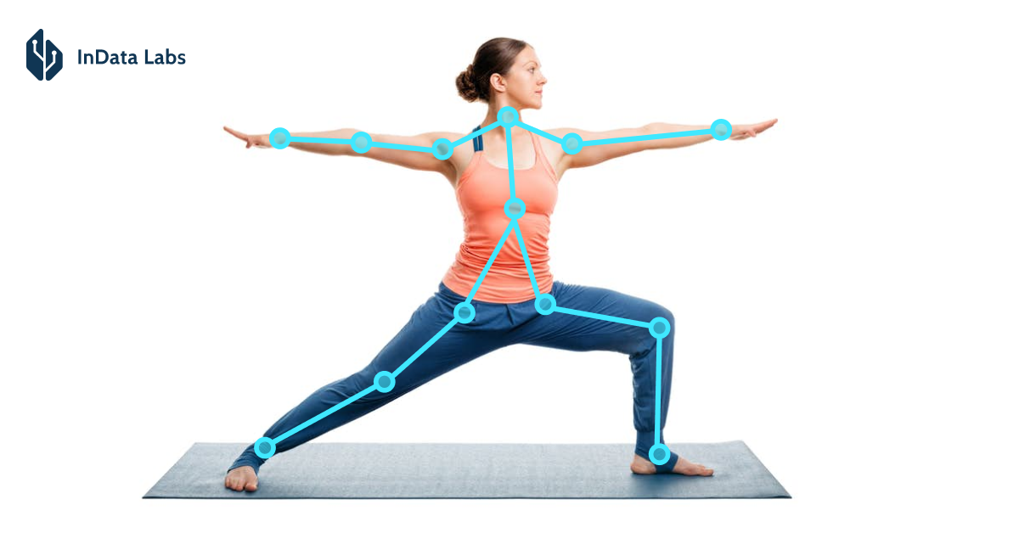](https://indatalabs.com/resources/human-activity-recognition-fitness-app)

(add novelty of pose score)

### notes

• Introduction (4 points): A brief description of the motivations behind your project, the goal of your project, why it is interesting or important, and why deep learning is a reasonable approach

* We’re interested in sports and posture applications to activities
  + Running, gym, paddling
  + Kinesiology movement

(maybe add research justification)

* Goal of project is to classify yoga poses
* Helps self-learning??
  + There is a student project with robot that corrects posture
  + “Analyzing human posture can identify and rectify abnormal positions, improving well-being at home”
  + <https://link-springer-com.myaccess.library.utoronto.ca/article/10.1007/s42452-023-05581-8>
* Deep learning can solve classification for the unlimited amount of possible postures/poses and people doing them

<https://www.kaggle.com/datasets/tr1gg3rtrash/yoga-posture-dataset>

<https://github.com/topics/yoga-pose-classification>

### Risk Register (4 points): Document 3-5 major/likely risks of the project, the likelihood of the risk, and what your team would do in the situation. For example, what would you do if a team member decides to drop the course? What would you do if your model training took longer than expected? Not all risks make sense for each project, so think about the risks involved with your project.